Assignment (ทฤษฎี) ครั้งที่ 2

วิชา 060243103 Problem Solving in IT

ตอนที่ 1

โดย

63-060216-2019-1 นาย สหรัถ ทองอินทร์

ห้อง IT 1-RA

เสนอ

ผู้ช่วยศาสตราจารย์สมชัย เชียงพงศ์พันธุ์

ภาควิชาเทคโนโลยีสารสนเทศ

คณะเทคโนโลยีและการจัดการอุตสาหกรรม

|  |  |
| --- | --- |
| **Given Data** | **Required Result** |
| Product Price  Member Status  Customer Pay | Discount Rate  Member Discount Rate  Price Discount  Member Discount  Net Price  Change |
| **Required Processing** | **Solution Alternatives** |
| Price Discount = Product Price * Discount Rate  Member Discount = Product Price * Member Discount Rate  Net Price = Product Price – Price Discount – Member Discount  Change = Customer Pay – Net Price | 1. Input Product Price, Member Status, Customer Pay.  2. Finding Member and Discount Rate by Compare Product Price and Member Status .  3. Calculate Price and Member Discount.  4. Calculate Net Price  5. Calculate Change |

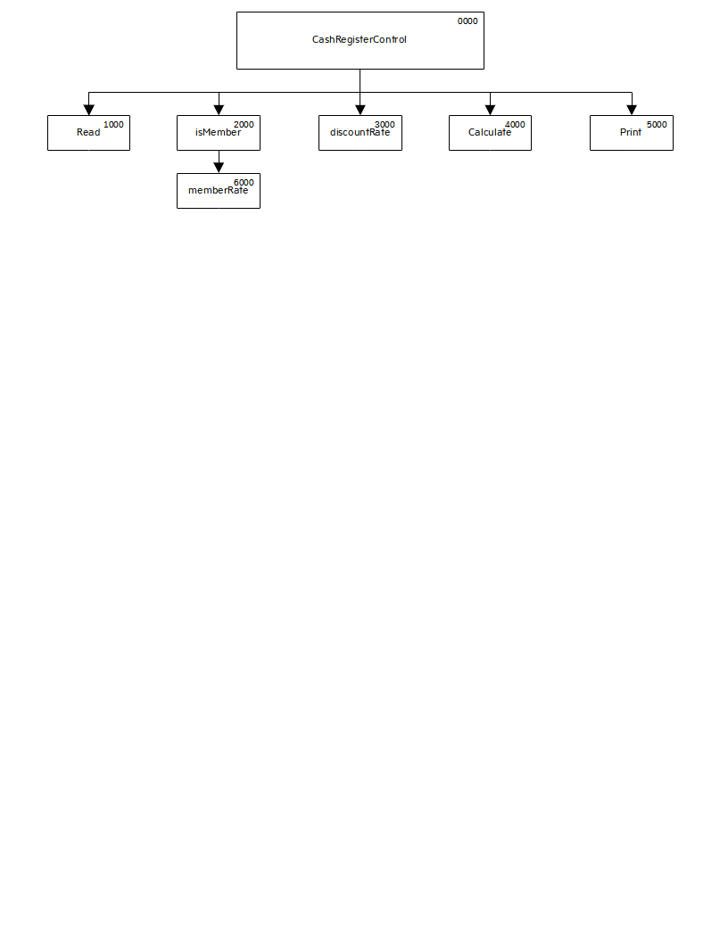

IPO Chart

**Problem Analysis Chart (PAC)**

|  |  |  |  |
| --- | --- | --- | --- |
| **Input** | **Processing** | **Module Reference** | **Output** |
| 1. Product Price  2. Member Status  3. Customer Pay | 1. Enter Input Data  2. Calculate Member Rate  3. Calculate Discount Rate  4. Calculate Price Discount, Net Price and Change  5. Print all Required Results | 1000  2000  3000  4000  5000 | All Required Results |

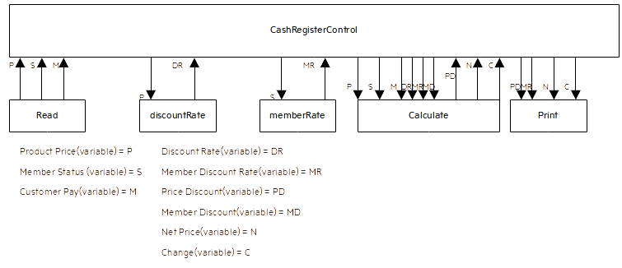

**IPO Chart**

**Coupling Diagram**

|  |  |  |  |  |  |  |
| --- | --- | --- | --- | --- | --- | --- |
| **Item** | **Variable Name** | **Data Type** | **Module** | **Scope** | **Pseudonym/ Module** | **Error Check** |
| Product Price | price | Real-Numeric | CashRegisterControl/ Read/discountRate/ /Calculate | Global Parameter | None | None |
| Member Status | member | Boolean | CashRegisterControl/ Read/isMember/member Rate/Calculate | Global Parameter | None | None |
| Customer Pay | pay | Real-Numeric | CashRegisterControl/ Read /Calculate | Global Parameter | None | None |
| Discount Rate | discount | Real-Numeric | CashRegisterControl/ isMember/memberRate | Global Parameter | None | None |
| Price Discount | price_discount | Real-Numeric | CashRegisterControl/ Calculate/ Print | Global Parameter | None | None |
| Member Discount | member_discount | Real-Numeric | CashRegisterControl/ discountRate/Calculate | Global Parameter | None | None |
| Net Price | netPrice | Real-Numeric | CashRegisterControl/ Calculate/ Print | Global Parameter | None | None |
| Change | change | Real-Numeric | CashRegisterControl/ Calculate/ Print | Global Parameter | None | None |

**Data Dictionary**